EWMA correlation: GBPUSD and USDJPY
Method 06 / daily log returns / lambda = 0.94 / Alpari D1 full available history

Study setup
Logical pair: GBPUSD , USDJPY
Broker symbols: GBPUSD_i , USDJPY_i
Snapshot: 2026-11-03_majors_alpari_D1
Timeframe: D1
Matched return window: 1999-01-05 to 2026-11-02 (UTC bar dates)
Matched return count n: 7200
Dropped unfinished last bar dated 2026-11-03 UTC after a tick-volume check against the prior complete day.
Lambda: 0.94 (today weight 0.06)
Burn-in ignored in path summaries and chart: first 60 updates
Mean adjustment: each leg demeaned by its mean on the matched rows
Seeds: c_0 = v_x,0 = v_y,0 = 0
Complete matched rows (Excel): GBPUSD-USDJPY_EWMA_D1.xlsx
Complete matched rows (HTML table): GBPUSD-USDJPY_EWMA_D1_data.html

Method carried forward
EWMA correlation updates covariance and variances of mean-adjusted daily log returns of close, ln(close_t / close_t-1), with lambda = 0.94 (6% weight on today's product or square, 94% on yesterday's EWMA state). Quotes are not inverted. Each leg is demeaned by its mean on the matched rows; that mean uses the full sample, so the rho path is a full-sample description, not a live filter. Seeds start at zero. Path summaries and the chart ignore the first 60 updates so the zero seed has faded. The headline is rho on the last day. rho is symmetric under swap of the two symbols. A high |rho| does not prove cause, lead-lag, or a trading signal. Today's return sits inside today's rho, so the estimate can only inform a later decision. Same-sample Pearson r is a side check only.

Results
Latest EWMA rho: -0.419698
Post-burn-in path (n=7140): mean=-0.279960, median=-0.305014, min=-0.819667, max=0.777508, std=0.282615
Share of post-burn-in days with |rho| >= 0.4: 38.94%; |rho| >= 0.7: 4.38%
Same-sample Pearson r: -0.198556
Latest rho minus r: -0.221143

Conclusion
Over 7200 matched daily log-return rows for GBPUSD and USDJPY (broker quote directions unchanged), latest EWMA rho with lambda=0.94 is -0.4197 (negative, moderate recent linear link in this sample). After a 60-day burn-in, path mean is -0.2800, std is 0.2826, and the range is [-0.8197, 0.7775]. Same-sample Pearson r is -0.1986 (latest rho minus r = -0.2211). This does not establish cause, lead-lag, or a lasting trading rule.

Charts
Daily closes

Daily log returns
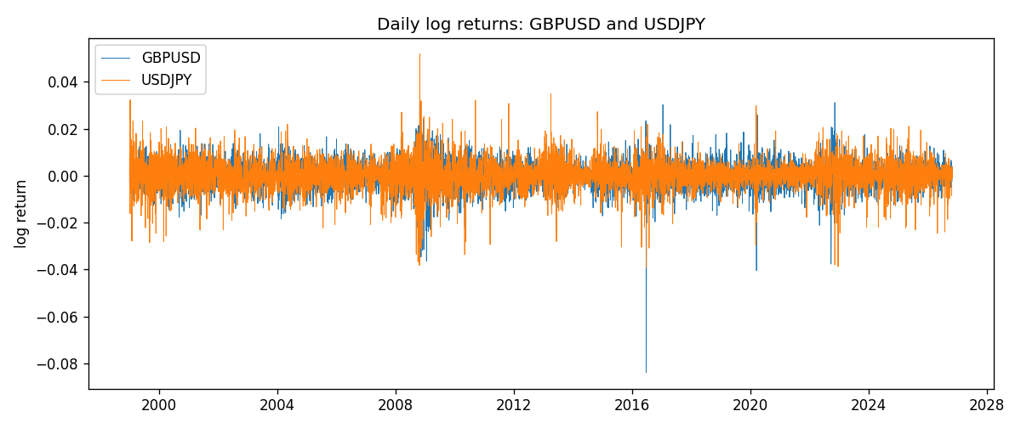
EWMA rho path with Pearson r reference
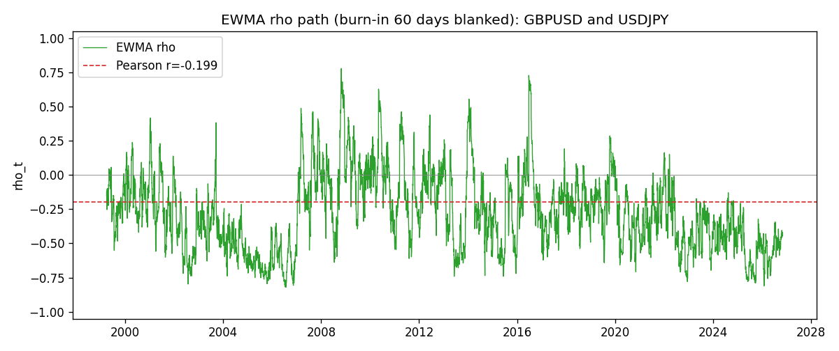

Data report
Every matched row that entered the EWMA recursion is stored in the sibling Excel workbook named GBPUSD-USDJPY_EWMA_D1.xlsx. That file is the complete data archive for redrawing charts. Embedding all rows as a Word table is impractical at this length; the Word file holds the column list, column summaries, and the first and last 15 matched rows.
Columns: time, GBPUSD_open, USDJPY_open, GBPUSD_high, USDJPY_high, GBPUSD_low, USDJPY_low, GBPUSD_close, USDJPY_close, GBPUSD_tick_volume, USDJPY_tick_volume, GBPUSD_spread, USDJPY_spread, GBPUSD_real_volume, USDJPY_real_volume, GBPUSD_log_return, USDJPY_log_return, GBPUSD_x_demeaned, USDJPY_y_demeaned, c_t, v_x, v_y, rho_t
Column summaries (matched calculation rows)
column | count | mean | std | min | 25% | 50% | 75% | max
GBPUSD_open | 7200 | 1.5159933 | 0.21821503 | 1.06854 | 1.3249725 | 1.51133 | 1.63163 | 2.1066
USDJPY_open | 7200 | 113.81122 | 19.205564 | 75.693 | 104.42925 | 110.991 | 120.69125 | 163.824
GBPUSD_high | 7200 | 1.5222906 | 0.21878569 | 1.08366 | 1.329785 | 1.518035 | 1.638315 | 2.1161
USDJPY_high | 7200 | 114.30876 | 19.267108 | 76.001 | 104.8815 | 111.4435 | 121.26 | 163.978
GBPUSD_low | 7200 | 1.5096683 | 0.2174426 | 1.03518 | 1.319445 | 1.50319 | 1.6243 | 2.0983
USDJPY_low | 7200 | 113.28793 | 19.133561 | 75.402 | 103.89 | 110.5305 | 120.17 | 163.628
GBPUSD_close | 7200 | 1.5160611 | 0.21817876 | 1.06879 | 1.3250775 | 1.511235 | 1.63193 | 2.1065
USDJPY_close | 7200 | 113.82409 | 19.220954 | 75.811 | 104.42 | 111.028 | 120.6855 | 163.851
GBPUSD_tick_volume | 7200 | 94838.03 | 153554.65 | 62 | 10001.75 | 52905.5 | 91812.25 | 1273370
USDJPY_tick_volume | 7200 | 106136.9 | 179308.31 | 149 | 9925 | 53095 | 92761 | 1803508
GBPUSD_spread | 7200 | 26.967917 | 19.192953 | 0 | 11 | 20 | 50 | 50
USDJPY_spread | 7200 | 20.325556 | 17.633971 | 0 | 6 | 11 | 30 | 50
GBPUSD_real_volume | 7200 | 3.5565837e+09 | 8.4444068e+10 | 0 | 0 | 0 | 0 | 2.4038164e+12
USDJPY_real_volume | 7200 | 3.470121e+10 | 1.6077679e+11 | 0 | 0 | 0 | 0 | 3.8834203e+12
GBPUSD_log_return | 7200 | -2.396e-05 | 0.00564572 | -0.08388241 | -0.0031301 | 3.232e-05 | 0.00317911 | 0.03112653
USDJPY_log_return | 7200 | 4.769e-05 | 0.00620489 | -0.03908203 | -0.00320192 | 0.00011421 | 0.00340709 | 0.05184024
GBPUSD_x_demeaned | 7200 | -0 | 0.00564572 | -0.08385845 | -0.00310614 | 5.628e-05 | 0.00320307 | 0.03115049
USDJPY_y_demeaned | 7200 | -0 | 0.00620489 | -0.03912973 | -0.00324962 | 6.651e-05 | 0.0033594 | 0.05179254
c_t | 7200 | -6.94e-06 | 1.926e-05 | -0.0001118 | -1.308e-05 | -7.07e-06 | -2.08e-06 | 0.00025732
v_x | 7200 | 3.185e-05 | 3.403e-05 | 4.9e-07 | 1.748e-05 | 2.389e-05 | 3.343e-05 | 0.00052544
v_y | 7200 | 3.847e-05 | 3.189e-05 | 0 | 1.904e-05 | 3.089e-05 | 4.766e-05 | 0.00041229
rho_t | 7200 | -0.27712639 | 0.28465929 | -0.81966667 | -0.49405688 | -0.30150524 | -0.09724787 | 1
First 15 matched rows (selected columns)
time | GBPUSD_close | USDJPY_close | GBPUSD_log_return | USDJPY_log_return | GBPUSD_x_demeaned | USDJPY_y_demeaned | c_t | v_x | v_y | rho_t
1999-01-05 | 1.6547 | 111.92 | -0.0028966287 | -0.00017868311 | -0.0028726694 | -0.00022637605 | 3.9018213e-08 | 4.9513377e-07 | 3.074767e-09 | 1
1999-01-06 | 1.6537 | 112.77 | -0.00060452184 | 0.0075660159 | -0.00058056258 | 0.0075183229 | -2.252143e-07 | 4.8564892e-07 | 3.3944011e-06 | -0.17540952
1999-01-07 | 1.6502 | 111.33 | -0.002118709 | -0.012851583 | -0.0020947497 | -0.012899275 | 1.4095438e-06 | 7.1978857e-07 | 1.3174215e-05 | 0.45773457
1999-01-08 | 1.6405 | 110.8 | -0.0058954193 | -0.0047719894 | -0.00587146 | -0.0048196824 | 3.0228855e-06 | 2.7450438e-06 | 1.3777523e-05 | 0.49154297
1999-01-11 | 1.6312 | 109.02 | -0.0056851331 | -0.016195423 | -0.0056611739 | -0.016243116 | 8.3588185e-06 | 4.5032746e-06 | 2.87812e-05 | 0.73422004
1999-01-12 | 1.6349 | 112.6 | 0.0022657001 | 0.032310364 | 0.0022896594 | 0.032262671 | 1.2289521e-05 | 4.5476305e-06 | 8.9507125e-05 | 0.60913502
1999-01-13 | 1.6499 | 113.52 | 0.0091330396 | 0.0081373171 | 0.0091569989 | 0.0080896242 | 1.5996751e-05 | 9.3058104e-06 | 8.8063218e-05 | 0.55880129
1999-01-14 | 1.6531 | 113.52 | 0.0019376331 | 0 | 0.0019615923 | -4.7692944e-05 | 1.5031332e-05 | 8.9783324e-06 | 8.2779562e-05 | 0.55136358
1999-01-15 | 1.6502 | 114.15 | -0.0017558204 | 0.0055343401 | -0.0017318611 | 0.0054866472 | 1.3559326e-05 | 8.619593e-06 | 7.9618986e-05 | 0.51759061
1999-01-18 | 1.6522 | 114.16 | 0.0012112405 | 8.7600193e-05 | 0.0012351997 | 3.9907249e-05 | 1.2748724e-05 | 8.1939606e-06 | 7.4841942e-05 | 0.51481033
1999-01-19 | 1.6553 | 113.52 | 0.0018745281 | -0.0056219403 | 0.0018984874 | -0.0056696333 | 1.1337977e-05 | 7.9185782e-06 | 7.228011e-05 | 0.47391729
1999-01-20 | 1.6472 | 112.91 | -0.0049053846 | -0.0053879917 | -0.0048814253 | -0.0054356846 | 1.2249731e-05 | 8.8731623e-06 | 6.9716104e-05 | 0.49251652
1999-01-21 | 1.6524 | 113.87 | 0.0031518998 | 0.0084664056 | 0.0031758591 | 0.0084187127 | 1.3118946e-05 | 8.9459374e-06 | 6.9785621e-05 | 0.52505289
1999-01-22 | 1.6565 | 114.56 | 0.0024781662 | 0.0060412564 | 0.0025021255 | 0.0059935634 | 1.3231608e-05 | 8.7848191e-06 | 6.7753852e-05 | 0.54234948
1999-01-25 | 1.6585 | 113.72 | 0.0012066366 | -0.0073594164 | 0.0012305959 | -0.0074071094 | 1.1890802e-05 | 8.3485919e-06 | 6.6980537e-05 | 0.50284048
Last 15 matched rows (selected columns)
time | GBPUSD_close | USDJPY_close | GBPUSD_log_return | USDJPY_log_return | GBPUSD_x_demeaned | USDJPY_y_demeaned | c_t | v_x | v_y | rho_t
2026-10-13 | 1.32534 | 158.305 | 0.0036434319 | -0.0018932826 | 0.0036673911 | -0.0019409755 | -6.4497183e-06 | 9.4684604e-06 | 1.9770289e-05 | -0.4714054
2026-10-14 | 1.31884 | 158.317 | -0.0049164679 | 7.5800166e-05 | -0.0048925087 | 2.8107221e-05 | -6.0709861e-06 | 1.0336551e-05 | 1.8584119e-05 | -0.43802653
2026-10-15 | 1.32757 | 158.024 | 0.0065976411 | -0.0018524319 | 0.0066216003 | -0.0019001249 | -6.461639e-06 | 1.2347094e-05 | 1.76857e-05 | -0.4372695
2026-10-16 | 1.33257 | 157.964 | 0.0037592051 | -0.00037976126 | 0.0037831643 | -0.00042745421 | -6.1709684e-06 | 1.2465008e-05 | 1.6635521e-05 | -0.4285375
2026-10-19 | 1.33024 | 158.517 | -0.0017500314 | 0.0034946841 | -0.0017260722 | 0.0034469912 | -6.1576956e-06 | 1.1895867e-05 | 1.6350295e-05 | -0.44152711
2026-10-20 | 1.3377 | 158.16 | 0.0055923442 | -0.0022546642 | 0.0056163035 | -0.0023023572 | -6.5640781e-06 | 1.3074687e-05 | 1.5687328e-05 | -0.45833561
2026-10-21 | 1.33937 | 158.108 | 0.0012476328 | -0.00032883504 | 0.0012715921 | -0.00037652799 | -6.1989608e-06 | 1.2387222e-05 | 1.4754595e-05 | -0.45853055
2026-10-22 | 1.33967 | 156.755 | 0.00022396082 | -0.0085942669 | 0.00024792009 | -0.0086419598 | -5.9555741e-06 | 1.1647677e-05 | 1.8350327e-05 | -0.40736345
2026-10-23 | 1.33684 | 156.81 | -0.0021146949 | 0.00035080446 | -0.0020907357 | 0.00030311152 | -5.6362632e-06 | 1.1211087e-05 | 1.725482e-05 | -0.40523989
2026-10-26 | 1.33359 | 157.458 | -0.0024340661 | 0.0041238746 | -0.0024101069 | 0.0040761817 | -5.8875294e-06 | 1.0886939e-05 | 1.7216446e-05 | -0.4300396
2026-10-27 | 1.33044 | 157.894 | -0.0023648393 | 0.0027651658 | -0.0023408801 | 0.0027174728 | -5.9159543e-06 | 1.0562505e-05 | 1.6626539e-05 | -0.44641668
2026-10-28 | 1.33254 | 157.743 | 0.0015771808 | -0.00095679538 | 0.00160114 | -0.0010044883 | -5.6574967e-06 | 1.0082574e-05 | 1.5689487e-05 | -0.4498153
2026-10-29 | 1.33733 | 157.683 | 0.0035881935 | -0.00038043789 | 0.0036121528 | -0.00042813083 | -5.4108353e-06 | 1.0260479e-05 | 1.4759115e-05 | -0.4396938
2026-10-30 | 1.33913 | 157.516 | 0.0013450605 | -0.0010596481 | 0.0013690197 | -0.0011073411 | -5.1771435e-06 | 9.7573027e-06 | 1.3947141e-05 | -0.44379533
2026-11-02 | 1.3406 | 157.933 | 0.0010971256 | 0.0026438521 | 0.0011210848 | 0.0025961591 | -4.691884e-06 | 9.2472744e-06 | 1.3514715e-05 | -0.41969805

